Computer Network Lab


Assissment # 0 1

Submitted By
QASIM ALI (20P-0070)
Submitted to : Hurmat Hidayat
(INSTRUCTOR CS)

DEPARTMENT OF COMPUTER SCIENCE

FAST NATIONAL UNIVERSITY OF COMPUTER AND EMERGING SCIENCES, PESHAWAR

Session 2020-2024

1. Setting Router Modes on 2600 Series Route

1. Access a Cisco 2600 Series Router via console or SSH/Telnet.
2. Start in User EXEC mode (">" prompt) for basic status.
3. Enter "enable" for Privileged EXEC mode ("#" prompt) for advanced commands.
4. Access Global Configuration Mode with "configure terminal" for global settings.
5. Configure interfaces or lines and save changes using "write memory."
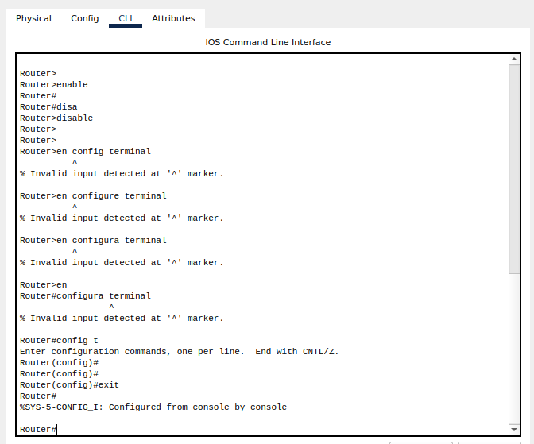

2:Changing Hostname of the Router?

>Access Privileged EXEC mode by entering the "enable" command.
>Enter Global Configuration Mode by typing "configure terminal" or "conf t."
>To change the hostname, use the following command:
hostname NEW_HOSTNAME
>Replace "NEW_HOSTNAME" with the desired hostname for your router.
>Exit Global Configuration Mode by typing "end" or pressing Ctrl+Z.
>Save the configuration to ensure it persists after a reboot:
write memory
>Your router's hostname is now updated to the new value you specified.
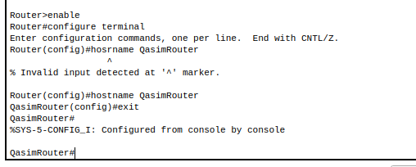

3:Configuring Date and Time on the Router (Clock Set Command)

To configure the date and time on a Cisco router using the "clock set" command, follow these steps:

1. Access Privileged EXEC mode by entering the "enable" command.
2. Enter Global Configuration Mode by typing "configure terminal" or "conf t."
3. Use the "clock set" command to set the router's date and time. The syntax is as follows:

clock set HH:MM:SS MONTH DAY YEAR

- Replace HH with the current hour (24-hour format).
- Replace MM with the current minute.
- Replace SS with the current second.
- Replace MONTH with the current month (e.g., JAN, FEB).
- Replace DAY with the current day of the month.
- Replace YEAR with the current year.

For example, to set the time to 2:30:00 PM on September 28, 2023, you would enter:

clock set 14:30:00 SEP 28 2023

4. Exit Global Configuration Mode by typing "end" or pressing Ctrl+Z.

The Cisco router's date and time should now be configured according to the values you specified with the "clock set" command.

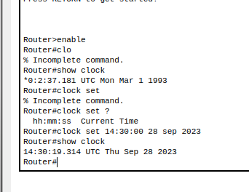

4: Setting a banner on the Router?

To set a banner on the router, you can configure a message that will be displayed to users when they access the router. This message is typically used for legal or warning notices. There are different types of banners you can set, such as login banners or message-of-the-day (MOTD) banners, each serving a specific purpose. You can customize these banners with your desired message to provide information or warnings to users accessing the router.

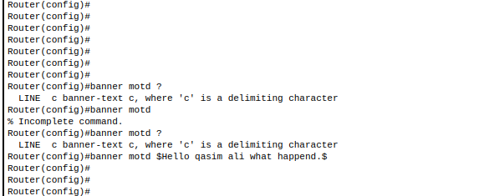

5:Displaying the Router’s Running-Configuration and Start-Up Configuration?

Running Configuration: This is the router's current configuration that it's actively using. It reflects the settings currently in effect and can be modified during the router's operation.

Startup Configuration: This is the router's saved configuration, which will be loaded and used when the router is rebooted or powered on. It's the configuration that persists across reboots and power cycles.

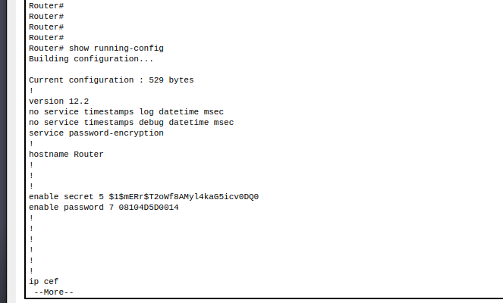

6: Enable Password and Enable Secret Password with the Encryption Techniques/Levels?

How to set up both an enable password and an enable secret password without specific commands:

Setting Up an Enable Password:
- To set up an enable password, you would enter a specific command in the router's configuration mode.
- You'll specify the desired password as plaintext in the command.
- The router will store this password in a weakly encrypted form within its configuration.

Setting Up an Enable Secret Password:
- To set up an enable secret password, you'll also enter a specific command in the router's configuration mode.
- You'll specify the desired password as plaintext in the command.
- However, the router will use a much stronger encryption method (MD5 hash) to store this password securely in its configuration.

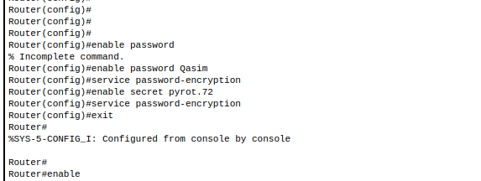

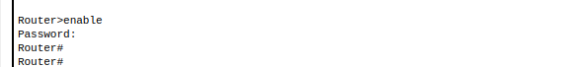

7: Usage of Router with different topology?

1. Star Topology:
- Usage: Suitable for small to medium-sized networks where devices connect directly to a central hub (router).
- Scenario: Commonly used in home networks, small offices, and branch office setups.

2. Mesh Topology:
- Usage: Provides redundancy and fault tolerance by offering multiple data paths. Routers determine the best path.
- Scenario: Employed in large corporate networks and data centers to ensure high availability.

3. Ring Topology:
- Usage: Devices are interconnected in a circular manner, with routers connecting different rings for data communication.
- Scenario: Often found in industrial networks, such as manufacturing and process control systems.

4. Internet Topology:
- Usage: Globally, the internet consists of interconnected routers directing traffic between networks.
- Scenario: The internet is the most extensive and vital example of router usage, enabling worldwide connectivity.

ETC.

